**Real time clock Using DS1307 RTC With Arduino UNO**

**Description:**

This Project is to design **Digital** **Clock** using DS1307 RTC With Ardunio Uno . This Digital clock can display We will be using a 16×2 LCD display the time and some other components. DS1307 is a low power serial real time clock with full binary coded decimal (BCD) clock/calendar plus 56 bytes of NV SRAM and The RTC provides year, month, date, hour, minute and second information.

### Materials Required:

* Arduino UNO
* DS1307 RTC Module with Built-in cell.
* 16×2 LCD Display
* Jumper Wires
* Breadboard
* USB Cable to connect Arduino UNO with your Computer

**Block Diagram:**

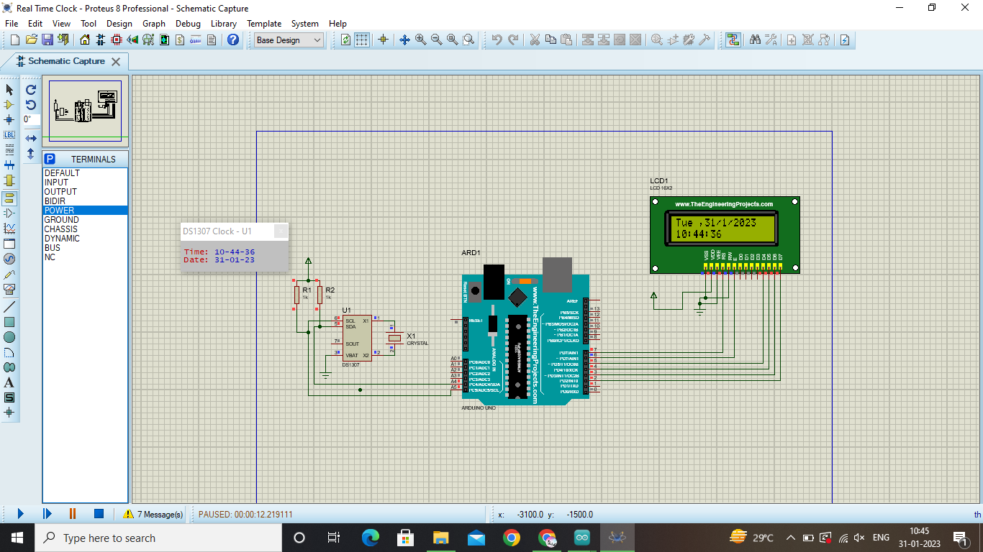

**Flow chart:**

Initialize the pins

Read the data and

time

Display time and on

LCD display